NT Assignment HTTP and Web Services
HTTP, REST

Task 1 : performing HTTP requests manually (putty)
With the help of PuTTY we ran the given command “GET /index.html HTTP/1.1 Host: www.example.com”. This command displays the metadata from the host, see Figure 1. With the help of the metadata their can be read what kind of content is displayed, when it was last modified, the cache, etc. After the metadata there is given the actual content of the requested resource.

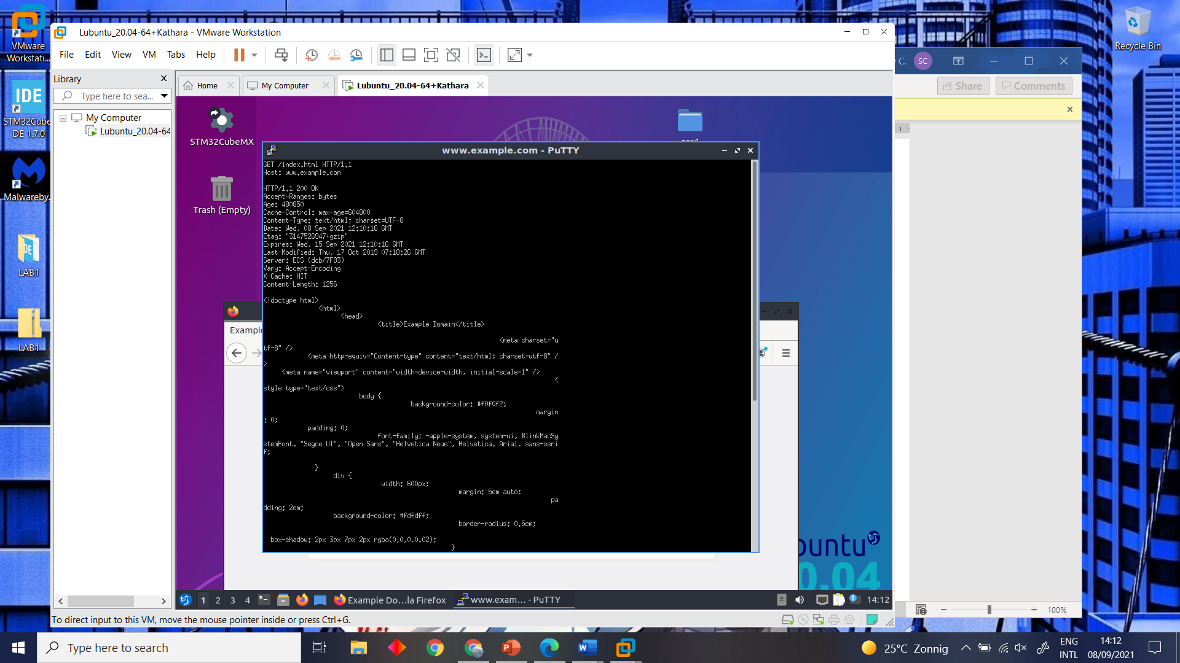
Figure 1 : retrieved metadata.

Task 2: Using cURL to do HTTP
With the help of cURL we could talk to the HTTP server. Due to this a command could be run to retrieve the same data as we had gotten in the previous task. Therefor we used the following command “curl --trace-ascii debugdump.txt http://www.example.com/”.

Besides retrieving metadata from a HTTP server, there is also the possibility to download an image from the server. In our case we downloaded an image/png, this could be found in the HTTP response header, content-type. To test this out, we ran the following command “curl -O https://www.google.nl/images/branding/googlelogo/2x/googlelogo_color_160x56dp.png”.

Lastly, there was a cURL command used to POST to the HTML-form in the following example; http://www.w3schools.com/tags/tryit.asp?filename=tryhtml_form_method_post .To post to this HTML-form example, there was made use of an command that allows us to post any string for the given values. The used command; “Curl -X POST –data “fname=he&lname=hee” https://www.w3schools.com/action_page.php”. See Figure 2.
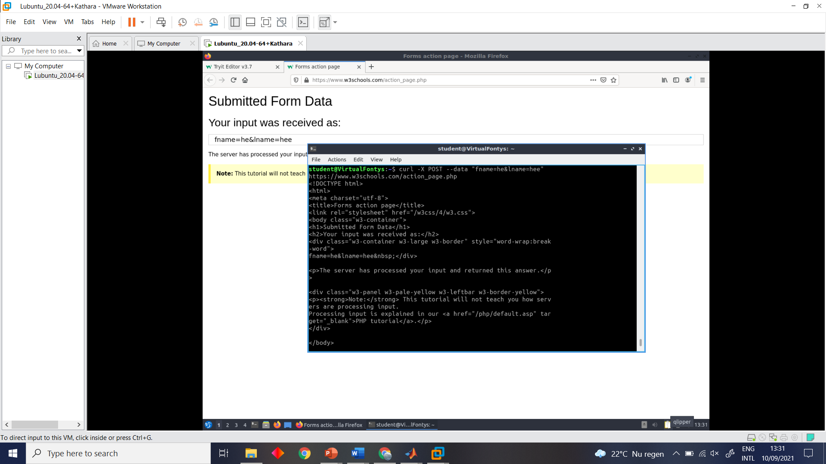
Figure 2 : retrieved metadata with cURL.

Task 3: Apache Web Server in the Kathara Lab
Regarding to staring up the apache web server, there is no need to start the server since it is already running. This is due to the fact that the start command is already written in the start up file, see line 2 “/etc/init.d/apache2 start”. Therefor another startup command is not necessary.
This was confirmed by running ‘service apache2 status’ just after starting the lab with the startup file without any modification. Should the server not be running it can be started using the ‘service apache2 start’ command.

With the help of the newly learned information from the previous tasks, we were able to retrieve data, with the help of lynx browser, from the given webserver. Besides that, we managed to change the page content. Therefor there is a before and after figure showcased. See Figure 3 and Figure 4.

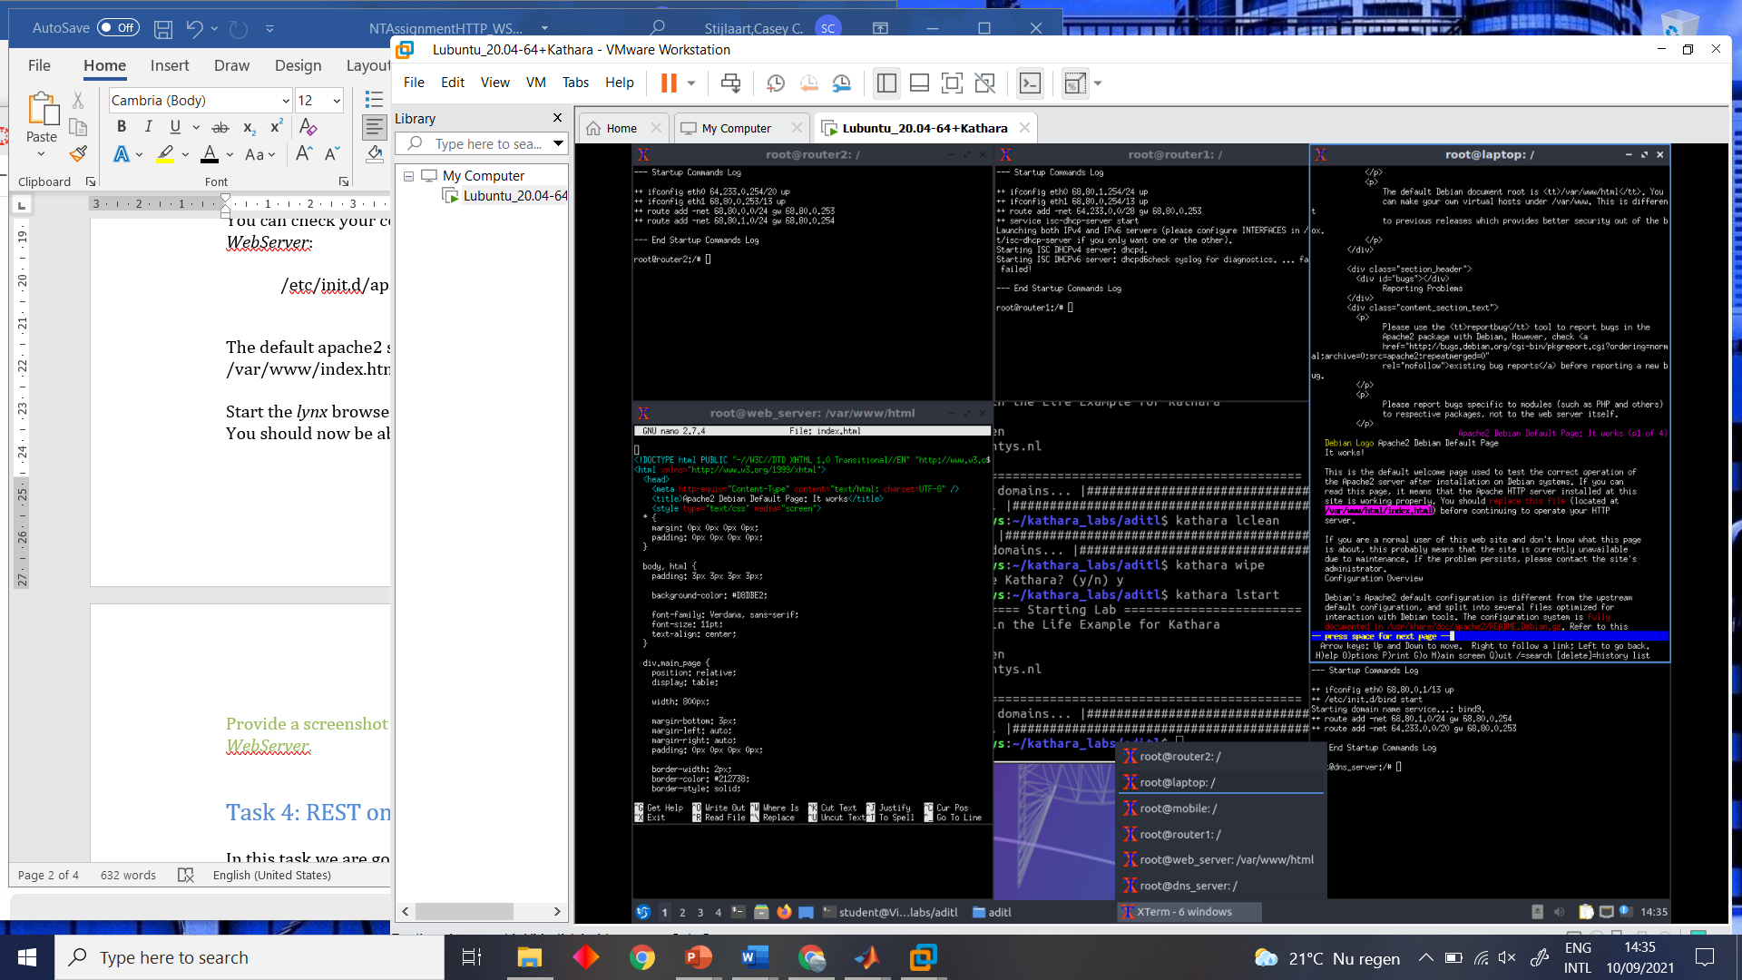
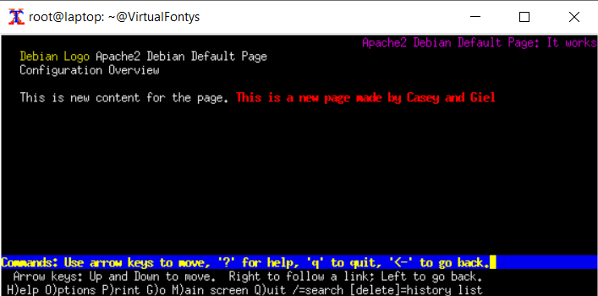
Figure 3 : lynx browser before.
Figure 4 : lynx browser after.

Task 4: REST on ESP32 board
In task 4 we made use of an ESP32 board, which is used for setting up a REST server. The created REST server allowed us to use HTTP GET and HTTP POST request to exchange data. Starting off, the HALL sensor is set up to continuously read it’s value in the loop. After that the data gets requested with a GET request trough the ESP’s server. During this request the HALL sensor’s data get’s read and returned to the client.

To check if this was working properly, we made use of the cURL GET command. The results of using this command is displayed in Figure 5.

Figure 5 : GET request hall.

With the help of the build in LED on the ESP32, we had to chance to use the POST and GET commands to control and read the LED. For controlling the LED we used two very similar command, these are as following; “Curl -X –data “state=true” http://esp32.local/led” and
“Curl -X –data “state=false” http://esp32.local/led”. See Figure 6.

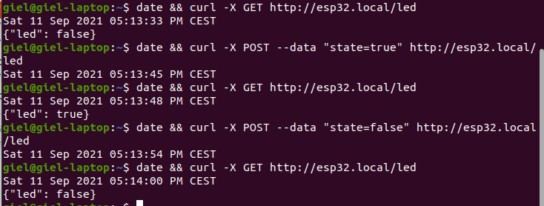
Figure 6 : GET/POST request LED.

The used ESP32 code is attached in the submitted folder.

